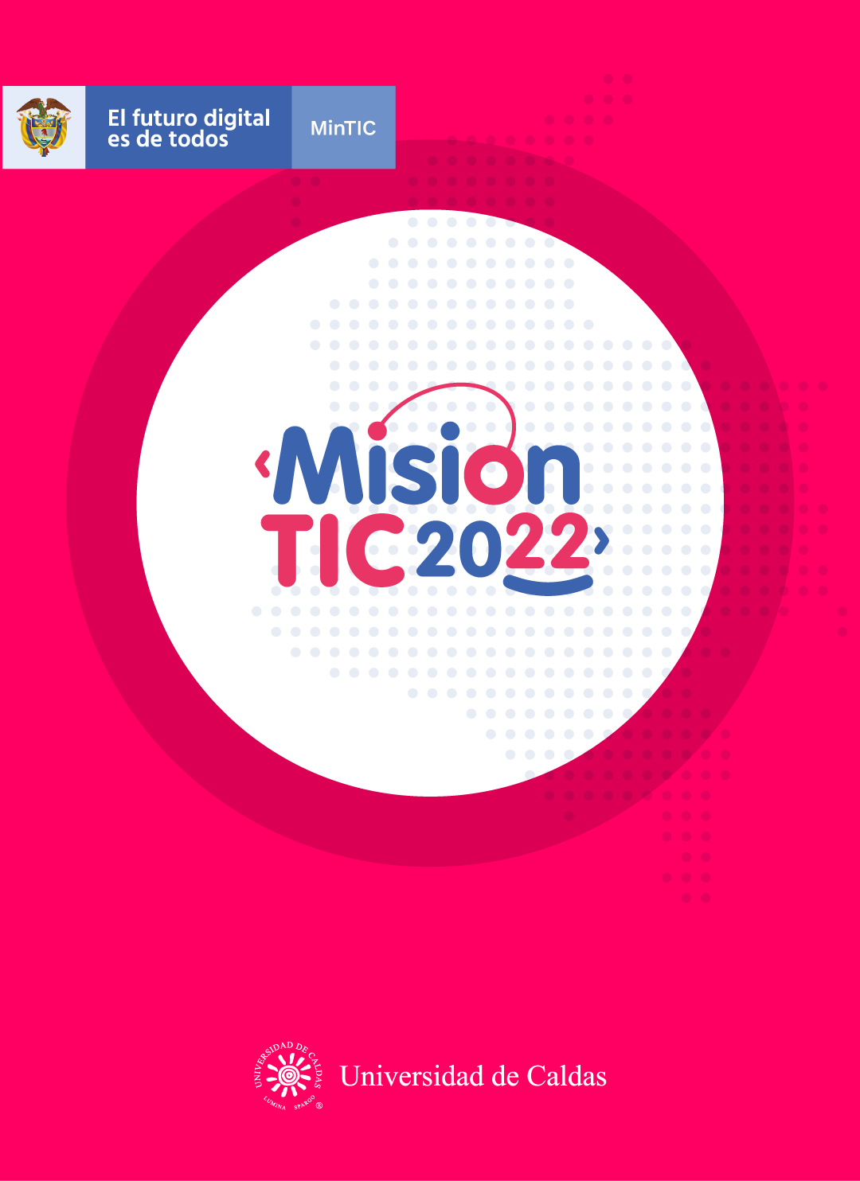

**WORKSHEETS**

**Problem solving and Critiquing**

**Worksheet 1.1**

**Criticize VS Critique?**

1. Which do you think is personal? Critique: for improvement
2. Which is objective? Critique: select positive
3. Which do you think is general? Criticize: only relate
4. Which is specific? Critique: seek objectively
5. Which do you think destroys? Criticize: point out the mistake
6. Which constructs? Critique: because it builds

[**https://www.youtube.com/watch?v=Yl-ikdyy6cg**](https://www.youtube.com/watch?v=Yl-ikdyy6cg)

**VOCABULARY**

**Development / Develop, Improvement / improve, Share, Wrong, Recipe, Choice, Peer, Critique Change**

**Complete the following sentences with the new vocabulary:**

**1.** There are many good universities in Colombia. It is so difficult to make a __choice_.

**2.** I didn´t pass the test because I had many __ Wrong_ answers.

**3.** Criticism is personal but ___Critique ___ is objective.

**4.** I have many good ideas. I want to ___ Share_____ them with my teacher.

**5.** People who work in software _ Development __ create new programs.

**6.** My grandmother cooks delicious food. Her cheesecake __Recipe_ is the best.

**7.** I have bad grades. I need to _ **improve** ___ my grades to pass the course.

**8.** In virtual classes, it is difficult to interact with your ___peer___.

**9.** I am very pessimistic. I need to __ **Change** ______ my attitude and become more optimistic.

**READING STRATEGY**

Watch the following video about “stop, ask yourself and re-read.

Practice this strategy with the examples.

<https://www.google.com/search?q=reread+strategy&oq=reread+stra&aqs=chrome.1.69i57j0l3j0i22i30l3.4474j1j7&sourceid=chrome&ie=UTF-8#kpvalbx=_hyBiYJK4JJGa5gKM36q4Cg36>

**Worksheet 1.2**

**Reading text**

Read the text. When you see a *stop* sign, stop reading and think if you understand what you read. If you don´t understand, go back and reread.

PROBLEM SOLVING AND CRITIQUING

Problem solving is an ability that everyone can develop. Problem solving is related to creativity. On some occasions, creativity is the development of new ideas. But on other occasions, creativity is the improvement of the existing ideas. *stop* A lot of improvement comes through sharing the ideas we have and critiquing the ideas of others. *stop*

We will begin with the idea that there are no wrong answers. And logically, all answers can be improved. That's a good starting point. *stop* To critique, one has to accept this starting idea of the other person, and have ideas about how to improve that idea. A lot of this, we learn from our own lives. *stop*

When we cook and experiment with a new recipe, sometimes it's good and sometimes it's bad. When it is bad, we need ideas on how to improve the food. *stop* we can change the quantity of food, the ingredients, the temperature, the spices, or the portion size. By making these choices, we're critiquing the original food design that is the recipe, because we want to improve the recipe for future use. *stop*

When we critique ideas, for example academic projects, the objective is to improve the idea and to help your peer improve their creative capacity.

This means we must be respectful of the other person and while emphasizing problems or difficulties we must offer solutions to improve the ideas presented. *stop*

Sometimes, when you generate new ideas for any project, you can also change any aspect of the project. It is always good to ask yourself questions to wake up your creativity: *stop* Was it more creative, or less creative? Have you done something similar, or different? Or is this result something you've never even imagined? What would happen if you made the project bigger or smaller? Or something that touched more people or something that was a different color? *stop*

But the most important thing is that you shouldn´t destroy the ideas - it is necessary to construct on the original idea from your peers. Then of course, you apply the same process of critique honestly to your own work. *stop*

**WORKSHEET 1.3**

**Correct these sentences. If necessary, reread the text to find the right answers.**

* Creativity is only limited to creating new ideas.

creativity is creating new ideas and improvement of the existing ideas __________________________________________________________

* Wrong answers cannot be improved.

all answers can be improved______________________________

* When we critique academic projects, we say negative things about them.

Not: new ideas are generated and refactored for improvement _____

_________________________________________________________

* When we critique, we focus on the problems.

it is like a recipe to objectively seek solutions and improvement __________________________________________________________

* When we critique, we destroy ideas.

is necessary to construct on the original idea from your peers from advance __________________________________________________

**Practice the new knowledge using this link.**

<https://wordwall.net/resource/15601166/class-1>

**WORKSHEET 1.4**

SELF –EVALUATION

Entiendo en qué consiste la estrategia de “reread”.

Yes ☺ Maybe :| No ☹

La estrategia “reread” me ayuda a concentrarme más cuando leo un texto.

Yes ☺ Maybe :| No ☹

Cuando vuelvo a leer, entiendo el texto mejor.

Yes ☺ Maybe :| No ☹

